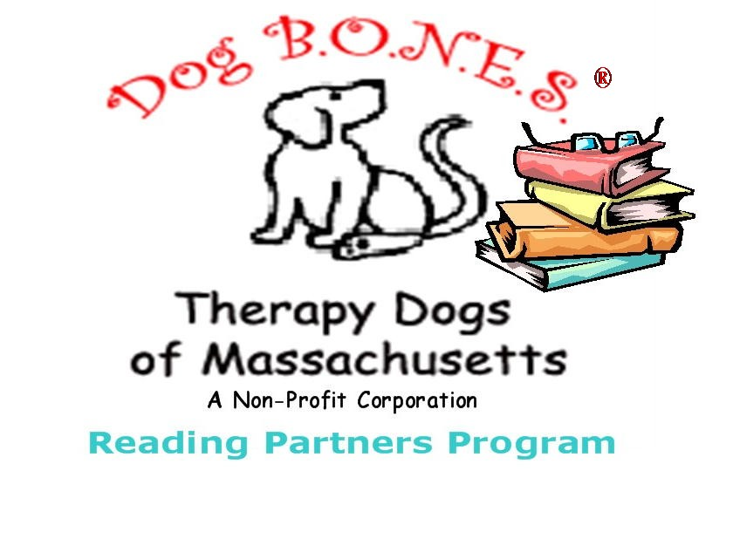

Capitalizing on the unique bond between animals and humans, visits by therapy dog teams has been proven to enhance the quality of life for people in many settings. Documented benefits include lowering blood pressure, provide comfort, motivate speech and movement, decrease loneliness and provide opportunities for nurturing, offering unconditional love and acceptance. This same bond is used by Dog B.O.N.E.S. Reading Partners to improve and enhance the literacy skills of children, while at the same time enhancing self esteem and reducing self consciousness so that children begin to look forward to reading.

Our Dog B.O.N.E.S. Reading Partner Program works with school and library personnel to set up short term programs. For instance, four Saturdays at the library; once a week for four weeks in a school setting.

How it works…..

The library setting:

Dog B.O.N.E.S. Reading Partners are scheduled in 15 minute blocks for an hour or two per session. The library signs up children from the community, generally in the K-6th grade age groups. The child picks out a book at the library to read to the dog. Because children are not chosen based on reading ability this program is used to help kids experience the library and reading in a fun and positive manner.

The school setting:

Dog B.O.N.E.S. works with the teaching staff to set up a program that meets the needs of their students so the student does not feel singled out because they are having difficulties. Instead we want children to feel special or rewarded.

For example:

Dogs may visit a classroom giving each child an opportunity to read to the dog during the visit.

Some schools set up space in their library. Children who would benefit from this type of intervention are selected by their teachers to participate.

After School programs may also be appropriate settings when supervised by a teacher or reading specialist.

