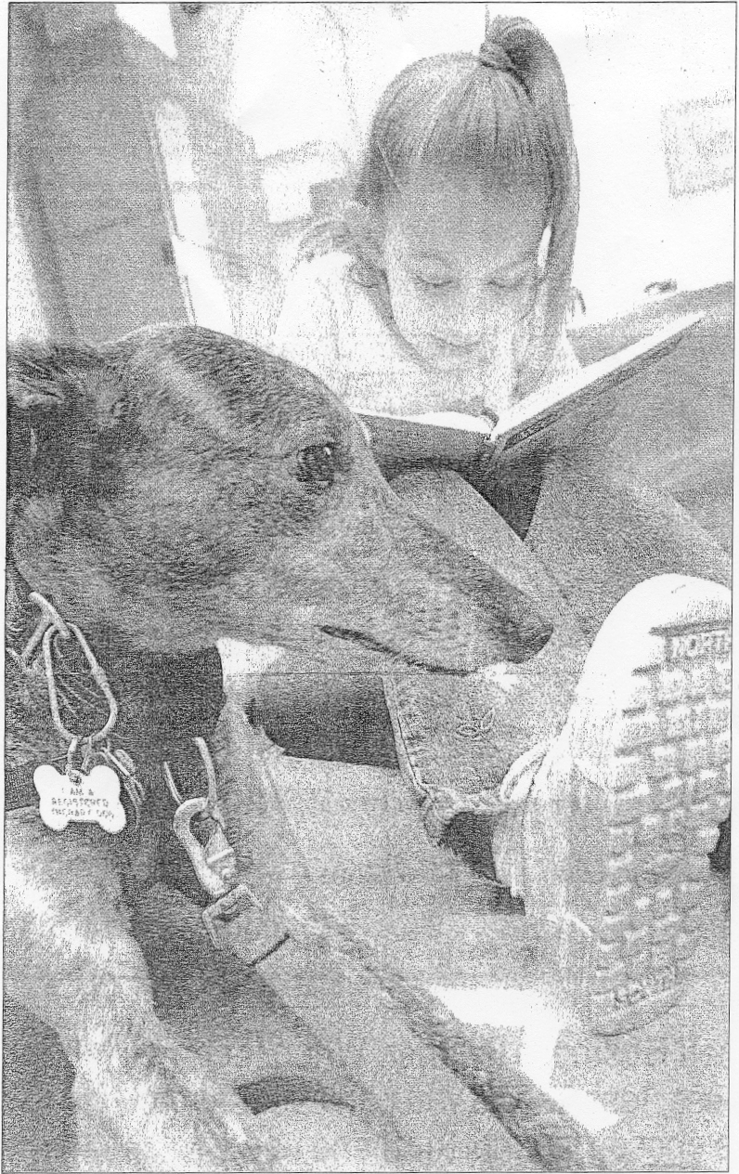

Olivia Gatti/Staff photo Kaitlyn Collins, 6, of Haverhill reads a "Word Bird" book to Willow, a greyhound, at Haverhill Public Library on Saturday. The program is run by librarians Kathy Alexander and Leslie Todd. Children who have trouble reading work with trained therapy dogs for practice because the dogs are .'nonjudge- mental" and don't correct children when they make mistakes.
